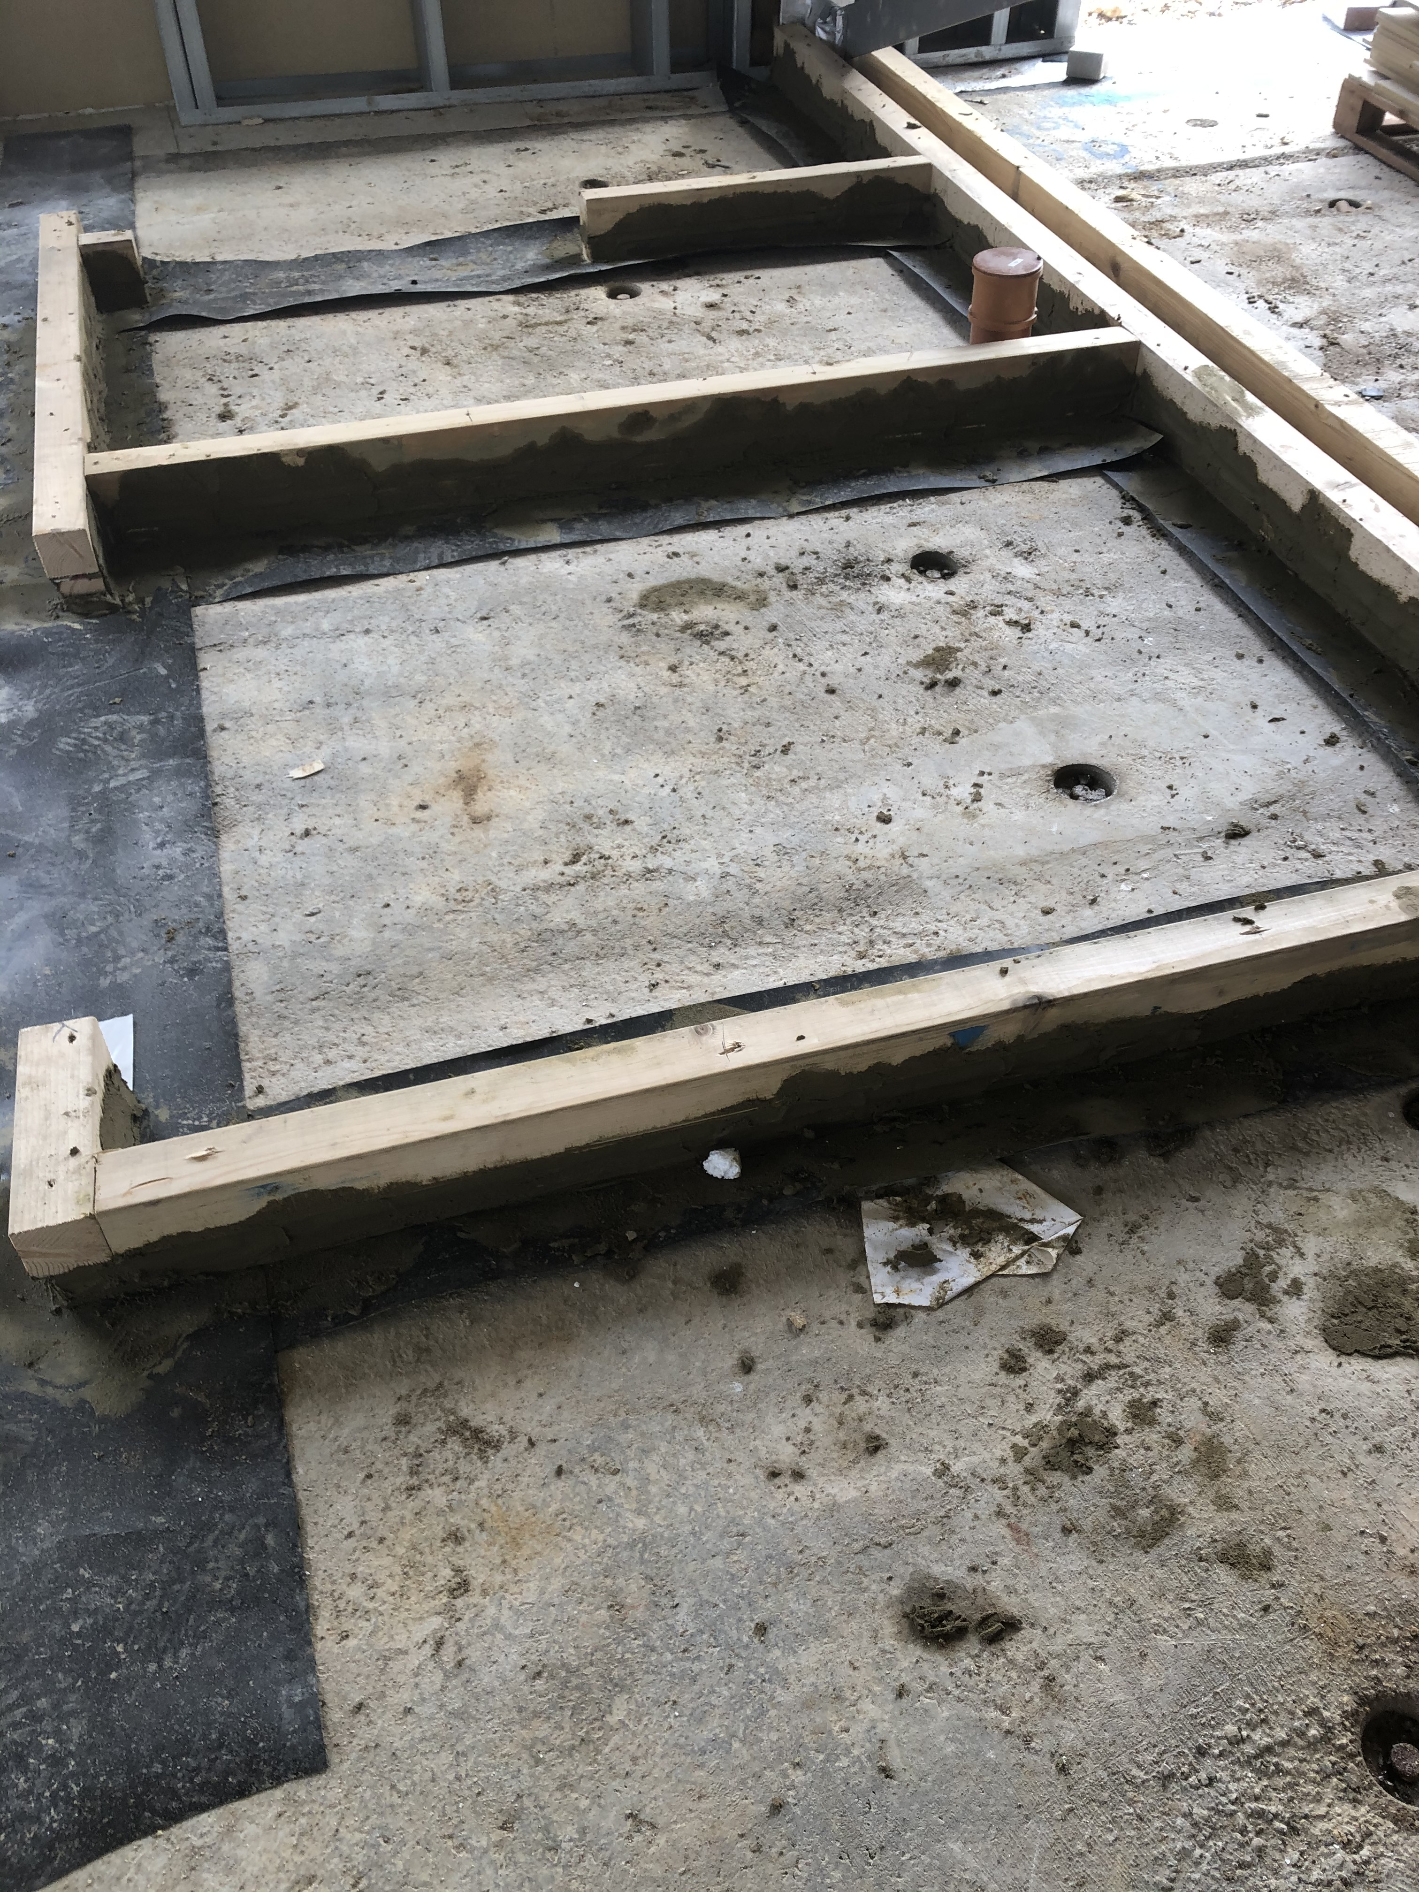
An update on Badbury Park Primary School
It’s starting to get really busy on site now we have started the main works including steel framing systems to achieve a watertight structure!
We are progressing inside the building with the base of the internal walling being installed and we can really start seeing the classrooms come together.
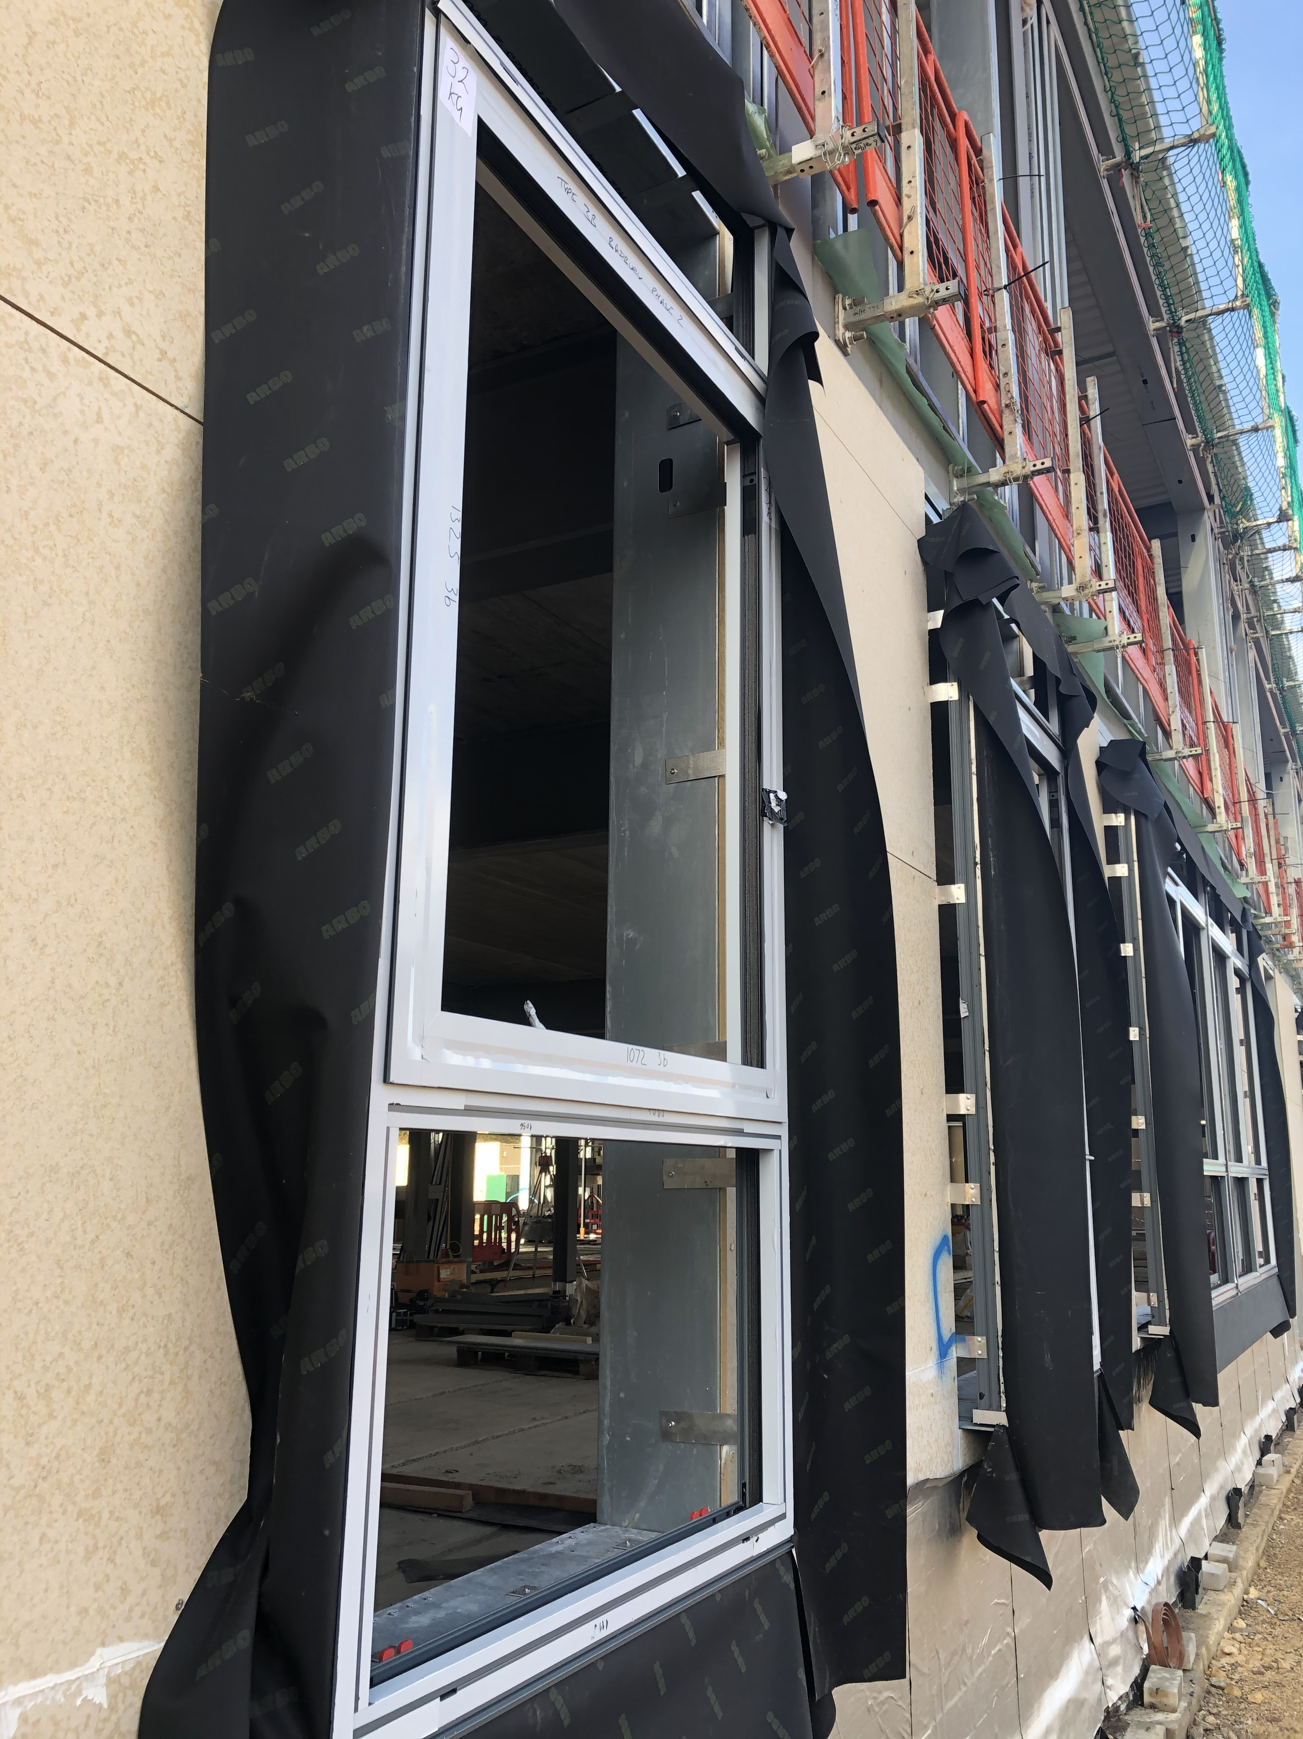
We have windows being installed on the ground floor in a light grey frame to help fit in with the local woodland area.
The base brickwork has also started which will soon create the finished look to the ground floor envelope!
Outside the building, the Multi Use Games Area (MUGA) pitch is taking shape so we can now start to see where the children will work and play.
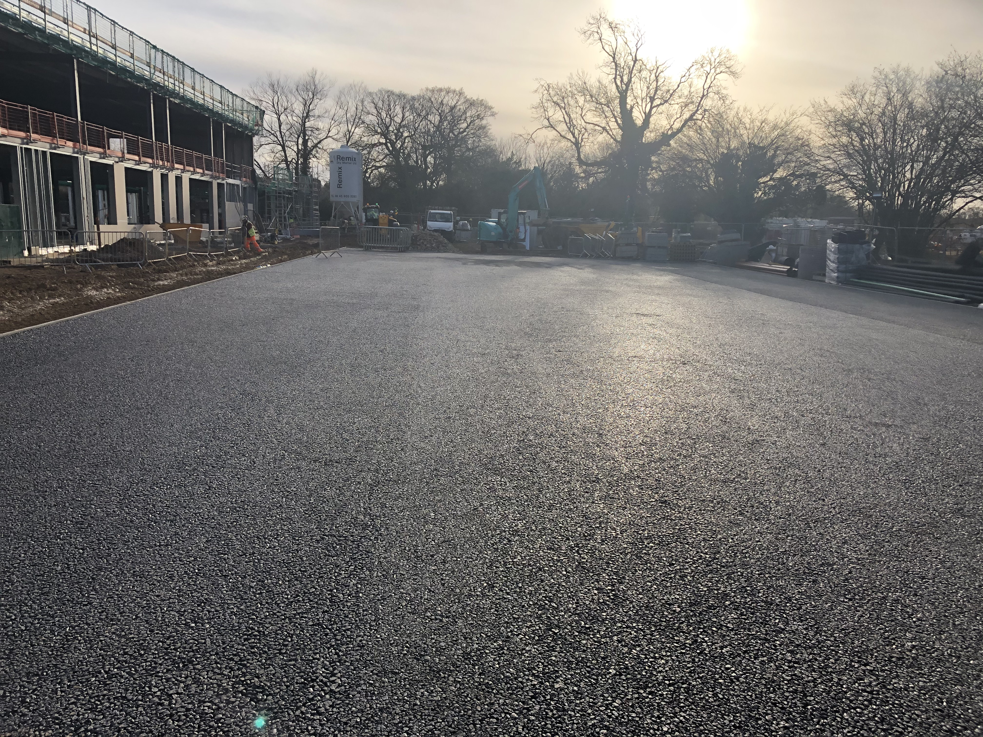
What’s coming next?
Over the next few weeks, we will be continuing to form the rooms inside the building, installing the windows and brickwork.
We will also be starting the underfloor heating which then allows us to screed and get the finished floor level. Once this has been achieved, we will start internal walls and mechanical and electrical services!
Monthly meet the team!
Jack Cooper, our new site manager, joined the team in February taking on the envelope package of Badbury Park Primary School.
He has worked on a vast variety of projects including the BBC Cymru Headquarters in Cardiff, The new school of Humanities for Bristol University and Bristol Business School for the University of West England. All of which have been successfully delivered to the delight of our clients.
Who are ISG?
Our vision is to become the world’s most dynamic construction services company, delivering places that help people and businesses thrive. Our 2,800 worldwide specialists in fit out, engineering services, construction and developments deliver not just buildings, but also an unbeatable customer experience.
In our industry, where speed and cost reign, we are committed to creating an unbeatable customer experience, and always want to have a positive effect on the people, environment and communities we work with.
We emphasise ‘care’. We believe the best outputs come from shared goals, mutual support and inclusive practices. As a result, we never run from responsibility; we aren’t afraid of having difficult conversations; and we make it our business to always be proactive, constructive and helpful.
Considerate Constructor
We are a founder member of the Considerate Constructors Scheme and take our role very seriously, working hard to minimise the impact of our works on local residents.
We are committed to minimising any inconvenience caused during the project so if you have any concerns, please contact project manager Mark Smith via email on mark.smith@isgplc.com.
Getting involved
We are keen to maximise the economic, social and environmental benefits to the local area as a whole during our time on site and plan to engage the labour force and community on this project as much as possible.
Training and skills
We are committed to providing a community skills and training legacy and will be working with our supply chain and training partners to ensure that local people can benefit from our involvement in this important regional project.
Community events
We want to engage with you, the local community, during this project and will be issuing regular updates and providing opportunities to meet the team as this development comes to life.

Jamie (our Apprentice Construction Manager) and Sophie (our Apprentice Quantity Surveyor) recently gave a talk to the class of the temporary Badbury Park Primary School on Construction. The students were really engaged with learning about the different trades that work on site, the development of the building from drawings through to the first lesson being taught on site. They enjoyed getting dressed up in the PPE to highlight working safely on a building site. The children were all inspired by the talk and are now actively taking part in our ‘Decorate the hoarding’ competition where the students are drawing pictures to help bring the site to life.

Contact us

ISG Bristol office 0117 923 6500

Name: Position: Email:
Mark Smith Project Manager mark.smith@igplc.com
Adam Makki Site Manager adam.makki@isgplc.com
Jack Cooper Assistant Site Manager jack.cooper@isgplc.com
Jamie Davis Apprentice Site Manager jamie.davis@isgplc.com

